## **Summit PowerApps Lab with Charles Sterling and Ted Pattison**

**Setup Time**: 60 minutes

**Lab Folder**: C:\SummitPowerAppLabs\

**Overview**: This lab covers how to get up and running with the Power Platform by creating a new Microsoft 365 tenant with trial subscriptions to Office 365, PowerApps, Flow, Power BI and SharePoint Online. The act of creating and configuring this new Microsoft 365 tenant will yield an isolated testing and development environment for building and testing the apps and components you can build with PowerApps and Flow. One valuable aspect of creating your own new Microsoft 365 tenant is that you will have Global tenant administrative permissions allowing you to create multiple Microsoft 365 user accounts for testing your apps and flows in isolation from any other existing Microsoft 365 tenant.

### Exercise 1: Setup a PowerApps Builders Environment

In this exercise, you will download a local copy of the student files from a GitHub repository named **SummitPowerAppsLab**

1. Launch a browser and navigate to the GitHub repository for this course at the following URL.

<https://github.com/CriticalPathTraining/SummitPowerAppsLab>

1. You should see the home page for the repository as shown in the following screenshot.

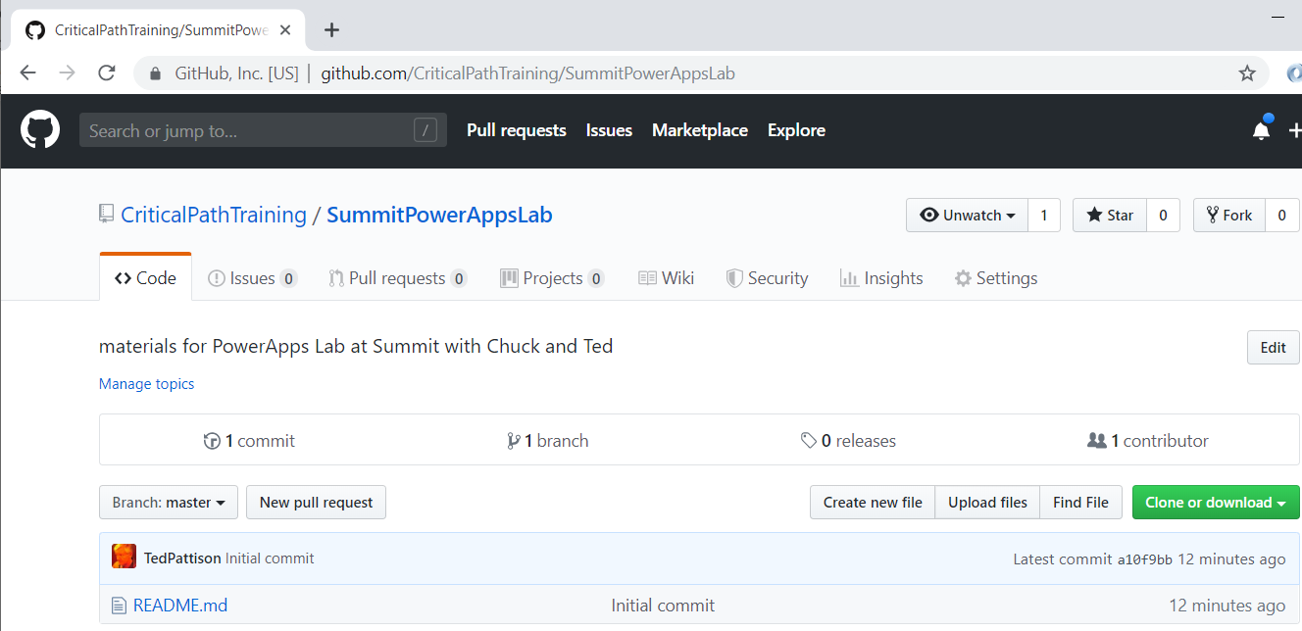

Note that you can examine the folders and the contents of individual files of this repository using the browser. However, it will be easier for you to download a local copy of the files from this repository as you work on these lab exercises.

1. Download the ZIP archive with the student files using the following URL:

<https://github.com/CriticalPathTraining/SummitPowerAppsLab/archive/master.zip>

1. Extract the contents of the zip archive into a local folder on your hard drive.

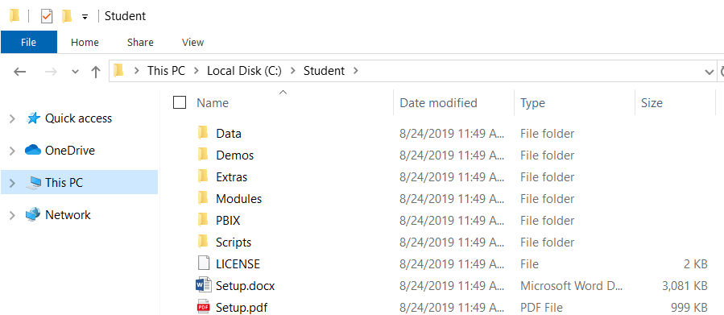

You can see that the student filescontain **Lab.pdf** and **Slides.pdf**.

#### Task 2: Sign Up for an Office 365 E5 Trial

In this task you will create a new Office 365 trial tenant. As you work through the sign up process for this free trial, you will be asked to provide a user name and a password for an Azure AD user account that will be configured as the tenant Global administrator. You will log in with this account when developing and testing applications that use Power BI embedding. However, it's a good practice that you also test your applications with standard user Azure AD accounts that have no administrative permissions. The trial tenant that you are going to create will allow you to create up to 25 user accounts with Office 365 E5 subscriptions. Remember that any user with an Office 365 E5 subscription is automatically assigned a Power BI Pro license as well.

1. Navigate to the Office 365 trial sign up web page.
   1. Launch the Chrome browser.
   2. Copy and paste the following URL into the address bar of the incognito window to navigate to the signup page.

<https://go.microsoft.com/fwlink/p/?LinkID=698279&culture=en-US&country=US>

* 1. You should now see the form you need to fill out to create your new **Office 365 E5** trial.
  2. Enter your email address and click **Next**.

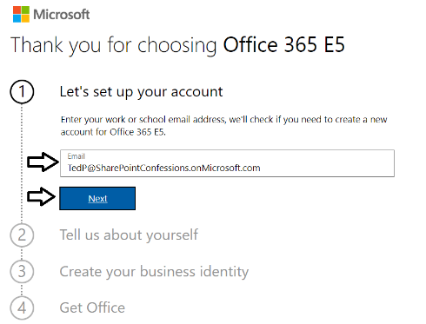

If you enter an email address for an organization account, the form provides the option to sign in. Do not click the **Sign in** button because you don't want to sign with an existing organization account. The purpose of this exercise is to create a new organizational account in a new Microsoft 365 tenant.

* 1. Click the **Create a new account instead** link.

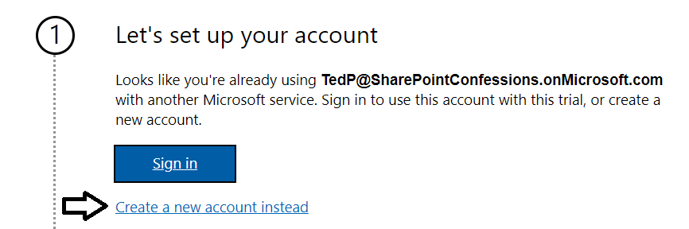

* 1. Enter your **First name** and **Last name**.
  2. Enter your mobile phone number as the **Business phone number**.
  3. Provides values for **Company size** and **Country or region** and click **Next**.

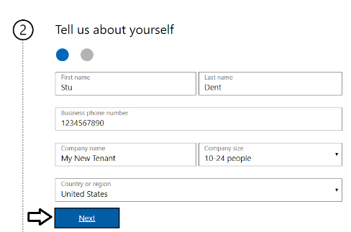

Whatever **Company name** you enter will be used as the name of the Azure AD tenant that will be created during the sign up process.

* 1. When prompted to prove you're not a robot, select the **Text me** option and ensure Phone number of for your mobile phone.
  2. Click **Send Verification Code**.

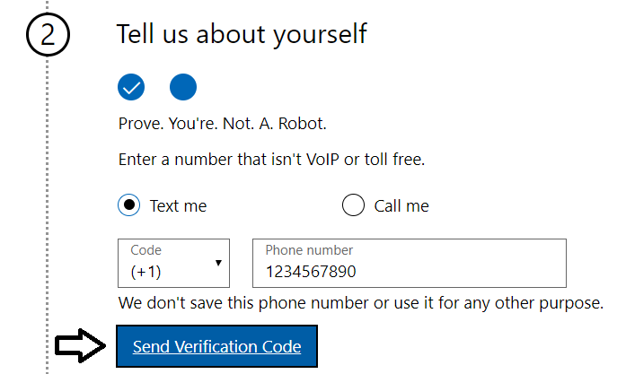

* 1. Retrieve the access code form your mobile device and use it to complete the validation process.

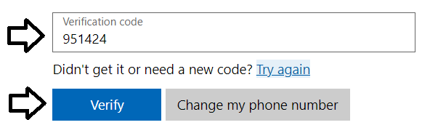

* 1. In the **Create your business identity** step, locate the textbox into which you will enter a domain name.

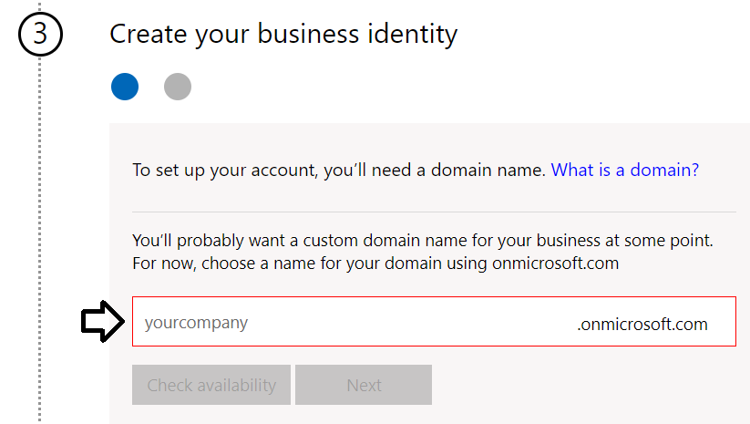

Note that the company name you enter in this textbox will be used to create an Internet domain name for a new Microsoft 365 tenant. For example, if you were to enter a company name of **cptstudent**, it would result in the creation of a new Office 365 tenant within a domain of **cptstudent.onMicrosoft.com**. The user name you enter will be used to create the first user account which will be given global admin permissions throughout the Azure AD tenant. If you enter a user name of **Student**, then the email address as well as user principal name for this account will be **student@cptstudent.onMicrosoft.com**

* 1. Enter a domain name for your new Microsoft 365 tenant.

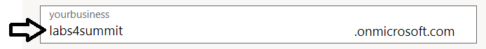

* 1. If the domain name you enter is not available, modify the domain name until you can verify that it is available.
  2. Once you have created a domain name that is available, click **Next**.

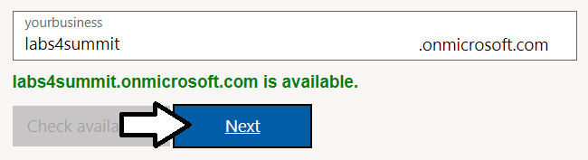

* 1. Enter a **Name** for your user account, a **Password** that you will remember and then click **Sign up**.

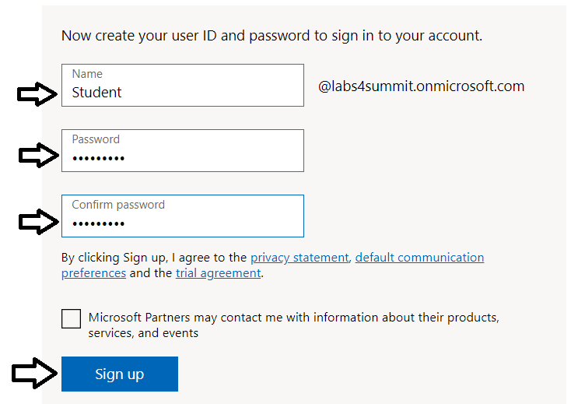

At this point, the Sign up process should begin to provision your new Microsoft 365 tenant and your new organizational account.

* 1. Once the provision process completes, take note of your new **user ID** and click the **Go To Setup** button.

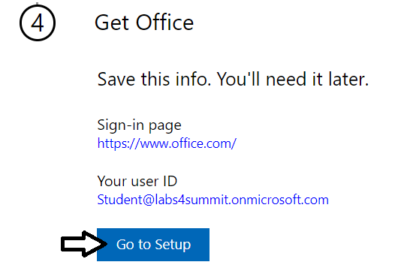

You have just created a new Microsoft 365 tenant with a 30-day trial for 25 Office 365 E5 licenses. Note that some Microsoft cloud services within your new tenant such as the Microsoft 365 admin center, Power BI, PowerApps and Flow can be accessed immediately. Other Office 365 services such as SharePoint Online, OneDrive for Business and your Outlook mailbox will not be ready immediately and can take some time to provision.

* 1. If you see the **Personalize your sign-in and email** setup page, click **Exit and continue later**.

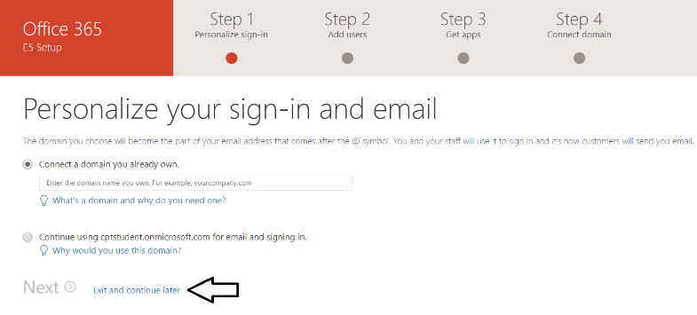

* 1. You should now be located at the home page of the **Microsoft 365 admin center**.

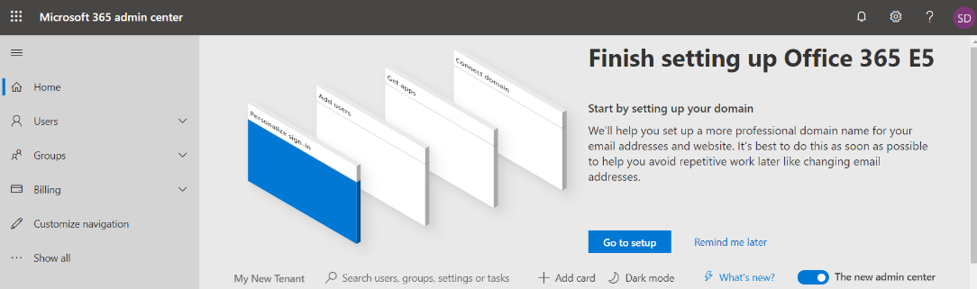

If you don’t see the home page of the **Microsoft 365 admin center**, navigate to <https://admin.microsoft.com/Adminportal>.

1. Inspect the set of active users in the current Azure AD tenant.
   1. Locate the top **Collapse navigation menu** with the hamburger icon just under the Microsoft 365 App Launcher menu.

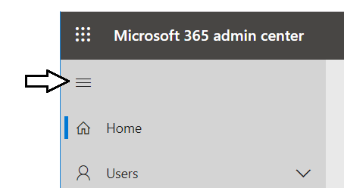

* 1. Toggle the **Collapse navigation menu** button to see how it collapses and expands the left navigation menu.

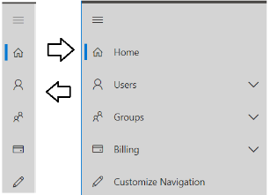

* 1. Navigate to the **Active users** view where you should be able to verify that the user account you are currently logged in as is the only user account that exists in the current tenant.

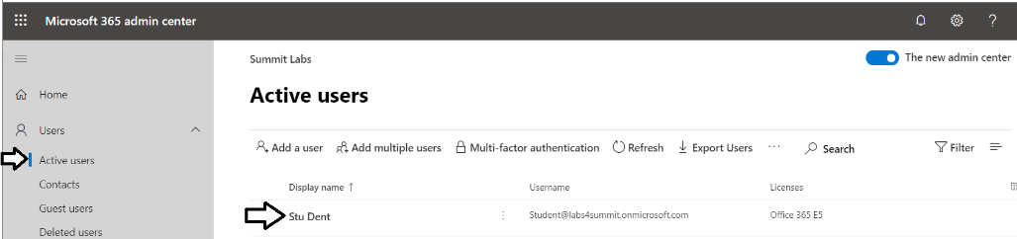

Remember that your account is global tenant administrator. You have permissions to configure any settings throughout the tenant.

1. Create a second Azure AD user account in your new Azure AD tenant.
   1. On the **Active Users** page, click the button **Add a user** button to create a new user account

. 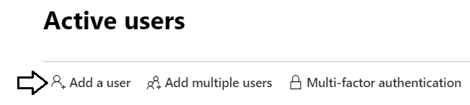

* 1. Fill in the **Set up the basics** form with information for a new user account. When creating this account, you can use any name you would like. These lab instructions will demonstrate this by creating a user account for a person named **James Bond** with a user name and email of **JamesB@labs4summit.onmicrosoft.com**.

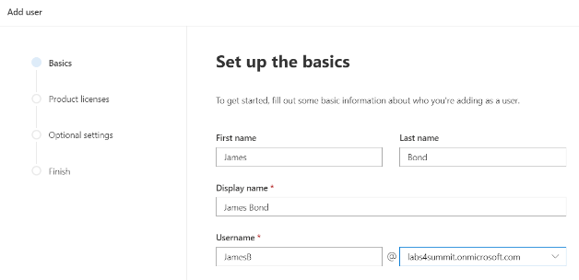

* 1. Move below to the **Password settings** section.
  2. Select the option for **Let me create the password**.
  3. Enter a password of **pass@word1** into the textbox labeled **Password**.
  4. Uncheck the checkbox for the **Require this user change their password when they first sign in** option.
  5. Click **Next**.

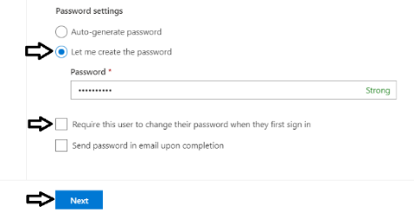

* 1. In the **Product licenses** section, make sure the **Office 365 E5** license is set to **On**.

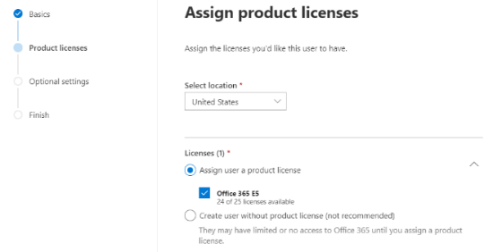

Note that the new account is usually assigned a trial license for **Office 365 E5** plan. However, it’s a good practice to check and make sure the new user has been assigned a license for **Office 365 E5**.

* 1. Click the **Next** button down below.
  2. On the **Optional settings** view, click **Next**.

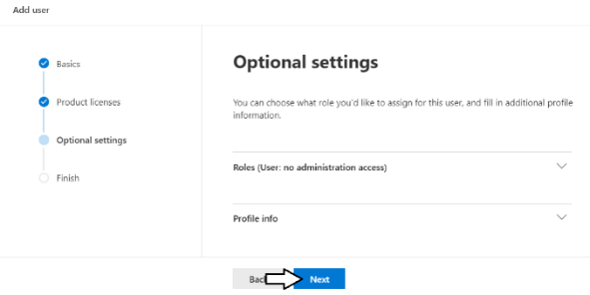

* 1. On the **Finish** view, Click the **Finish adding** button at the bottom to create the new user account.

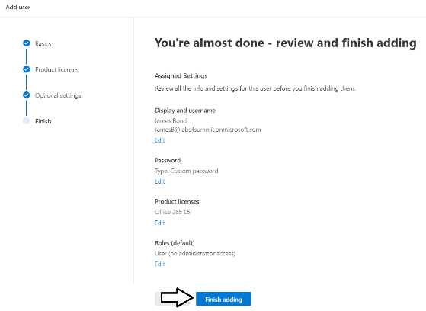

* 1. You should see the **Finish** view with a message indicating that the new user account has been created.

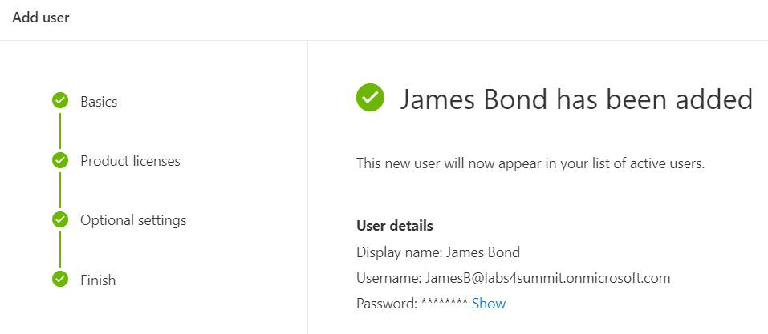

* 1. Click the **Close** button at the bottom of the **Finish** view to close the **Add User** pane on the right.
  2. Verify that the new user account has been created and is displayed along with your primary Office 365 user account.

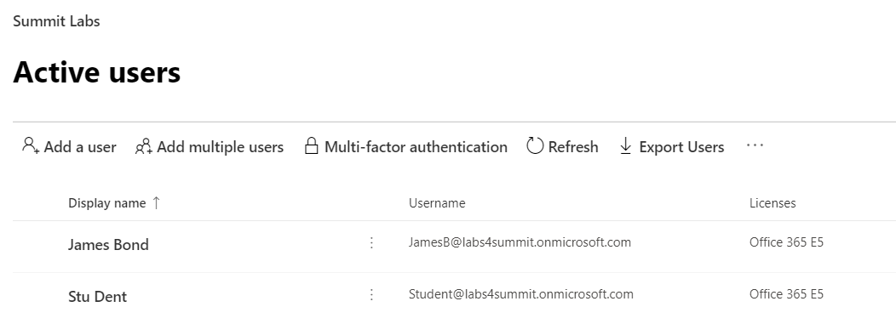

Now you have a secondary user account that does not have any administrative permissions. It's important that you test applications which use first-party embedding with standard user accounts to ensure your application doesn't require users with special permissions.

#### Task 3: Create a Trial Subscription for PowerApps Plan 2

In this exercise, you will configure your new Microsoft 365 tenant by creating a new subscription based on PowerApps Plan 2.

1. Navigate to the home page of the Microsoft 365 Admin center.
2. Create a new subscription for PowerApps Plan 2.
   1. Click on **Billing** in the left navigation to expand the menu items underneath.

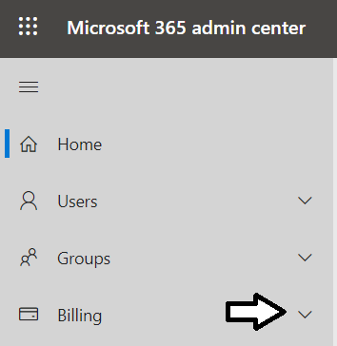

* 1. Click on the **Purchase services** navigation link.

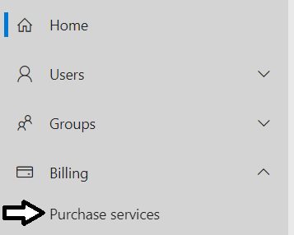

* 1. Type "PowerApps" into the search box to search for PowerApps subscription plans.

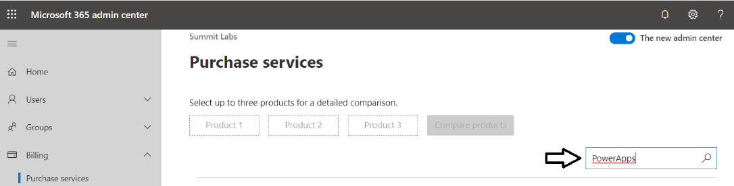

* 1. Find the subscription with the name **Microsoft PowerApps Plan 2**.and click on it to select it.

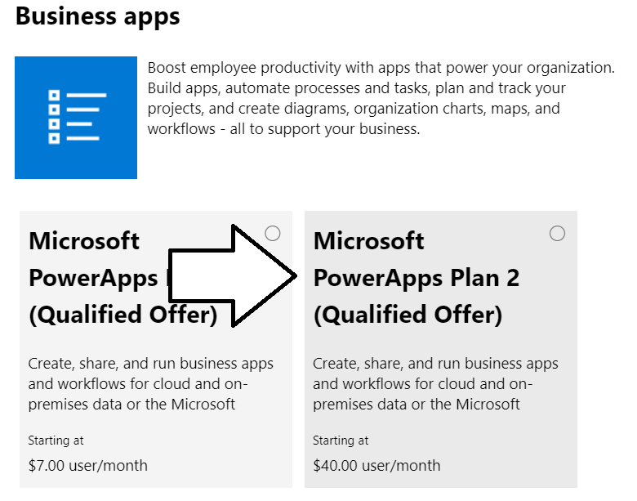

* 1. Click the **Start free trial** button

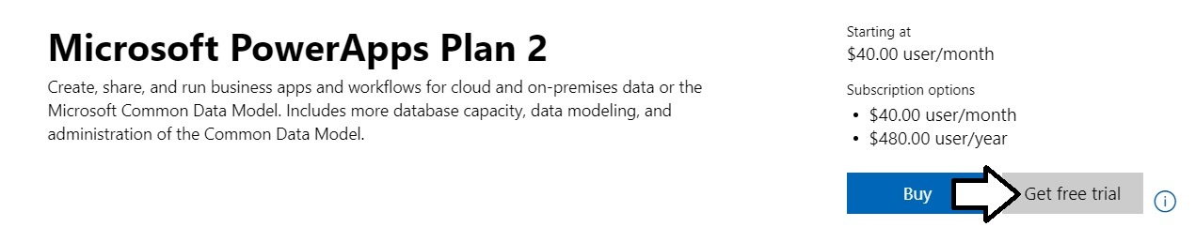

* 1. When prompted to confirm your order, click **Try now**.

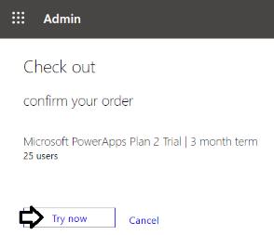

* 1. You should see an order receipt to confirm you have created the new trial subscription.

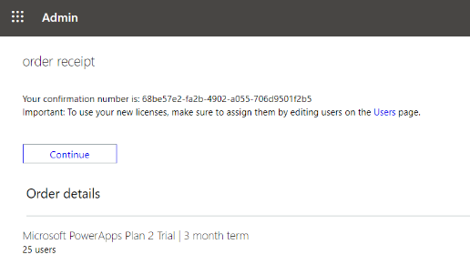

1. Configure your user account by assigning a PowerApps Plan 2 license.
   1. Navigate back to the **Active Users** page in the Office 365 Admin center.
   2. Click on your user account to edit it.

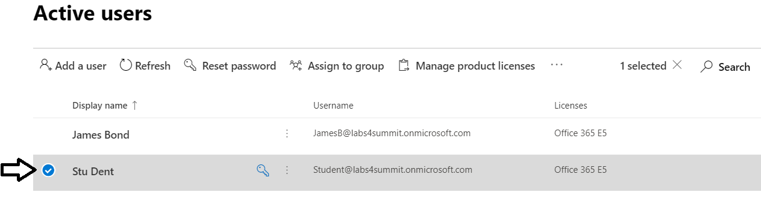

* 1. Click the **Licenses and Apps** link.

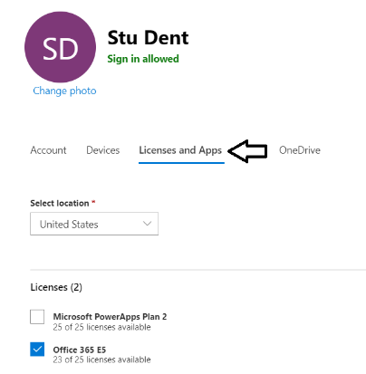

* 1. Enable the **Microsoft PowerApps Plan 2** subscription and then click **Save changes** below.

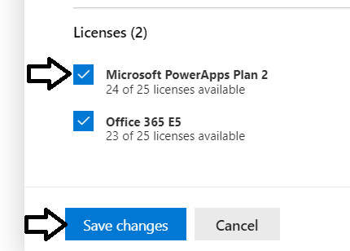

After creating a new subscription for PowerApps Plan 2, it might take a minute or two before it shows up in the Product licenses dialog.

* 1. You should be able to confirm your user account has been configured with a **Microsoft PowerApps Plan 2** subscription.

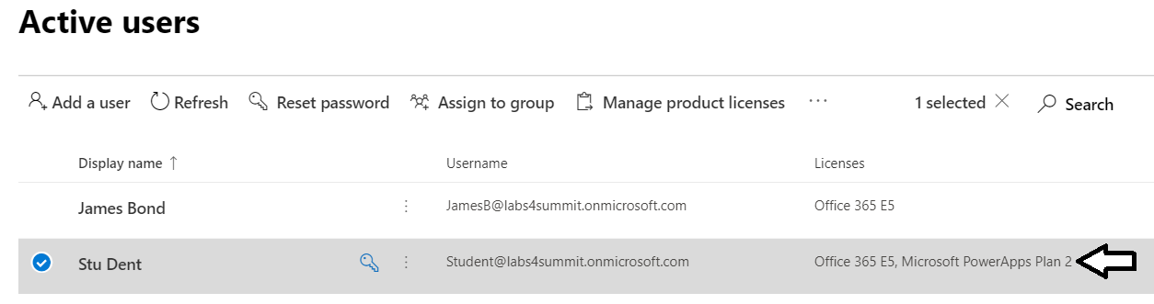

You will need the Microsoft PowerApps Plan 2 subscription to create a new PowerApps environment with a Common Data Service database. The PowerApps Plan 2 provides the licensing beyond the Office 365 license such as the ability to use premium connectors and custom connectors.

### Exercise 2: Create a New PowerApps Environment

In this exercise, you will create a new PowerApps environment with a PowerApps portal.

1. Navigate to the PowerApps Admin center.
   1. In the browser, navigate the PowerApps Maker portal at [https://make.powerapps.com](https://make.powerapps.com/).

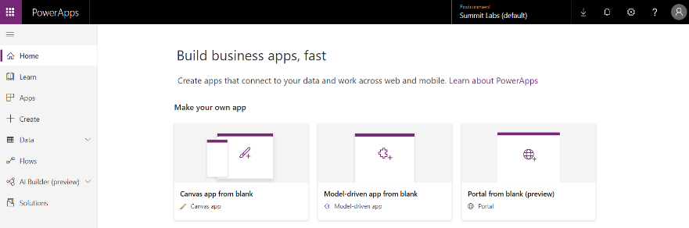

* 1. Drop down the menu with the gear icon in the upper right of the page and select the **Plan(s)** command.

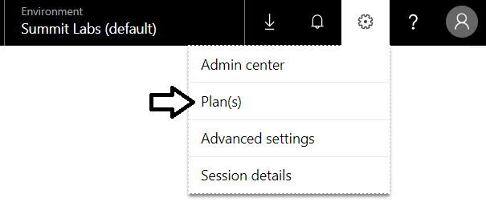

* 1. You should be able to verify that you have Plan 2.

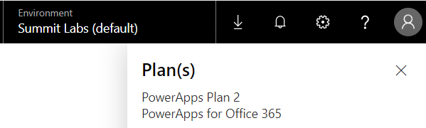

* 1. Drop down the menu with the gear icon in the upper right of the page and select the **Admin center** command.

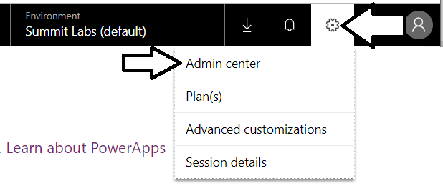

1. Create a new PowerApps environment with a Common data Service database.
   1. In the **Power Platform Admin center**, click the **Environments** link in the left navigation.

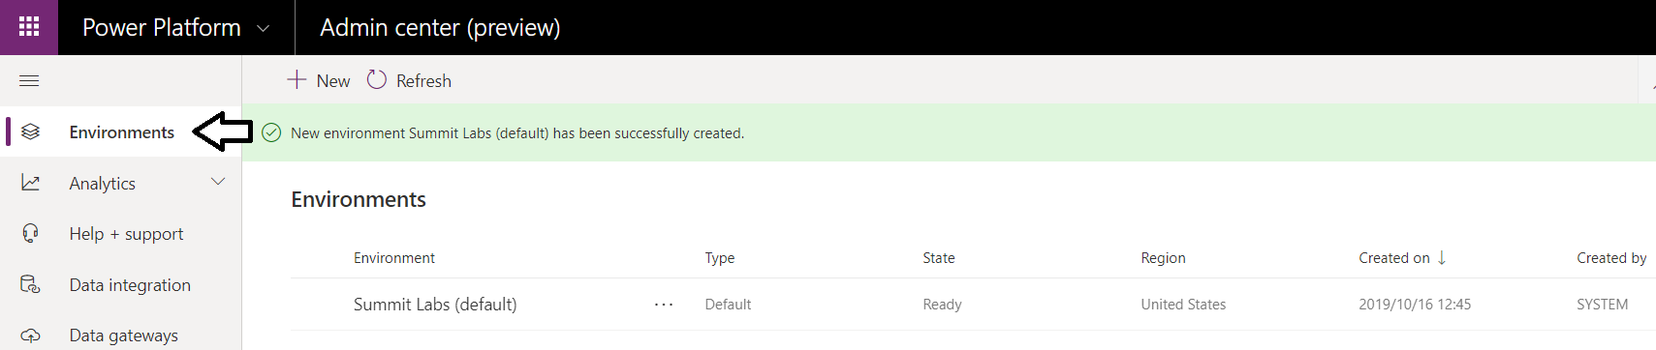

* 1. If you see an informational message about the default environment, dismiss it by clicking the **X** in the upper right corner.

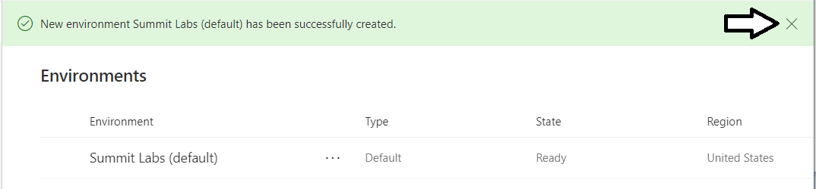

* 1. Click the **+ New** button to create a new environment.

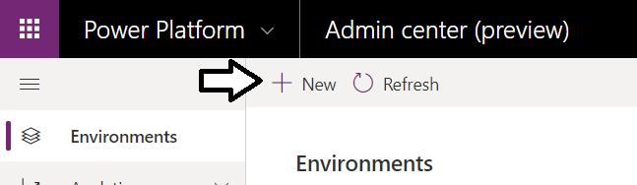

* 1. In the **New environment** pane on the right, enter a Name of **My Dev Environment**.

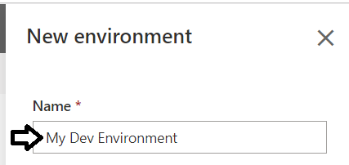

* 1. Make sure you enable the option **Create a database for this environment**.
  2. Once you have filled out the **New environment** pane, click **Next**.

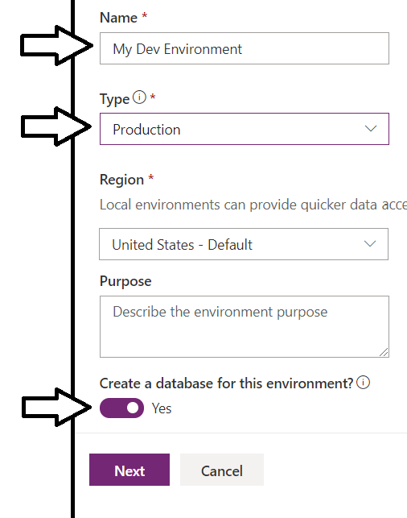

* 1. Leave the default setting on the **Add database** pane as shown in the following screenshot
  2. Click **Save**.

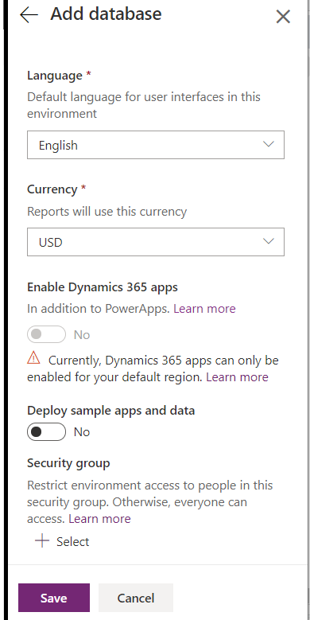

* 1. You should now see the new environment in the tenant **Environments** list with a **State** or **PreparingInstance**.

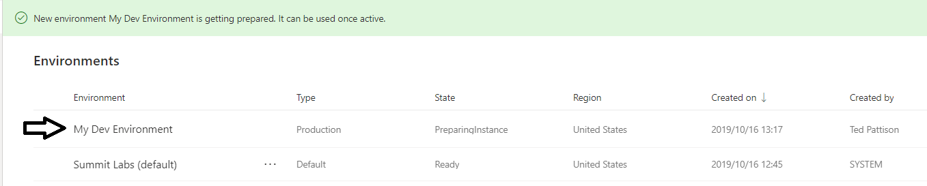

* 1. Refresh the Environments list every 30 seconds until you see that he **State** has turned to **Ready**.

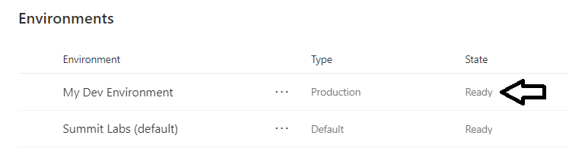

1. Create a PowerApps portal in your new PowerApps environment.
   1. Return to the PowerApps Maker portal at [https://make.powerapps.com](https://make.powerapps.com/).
   2. Refresh the page at <https://make.powerapps.com> by pressing **{F5}**.
   3. Drop down the Environments menu at he top right of the page.

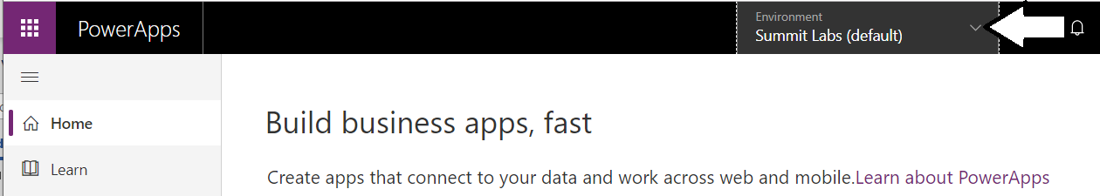

* 1. Switch over to the new environment you just created named **Portal Lab**.

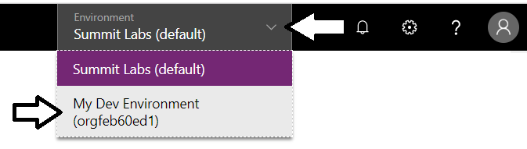

* 1. Click on the **Portal from blank (preview)** tile to create a new PowerApps portal.

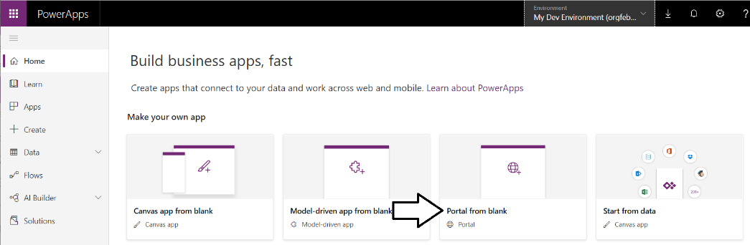

During the PowerApps portal preview, you can only create one portal per environment. If you want to create multiple portals, you will have to create a separate PowerApps environment for each one.

* 1. In the **Portal from blank (preview)** dialog, enter a portal tile such as **My Portal Lab**.

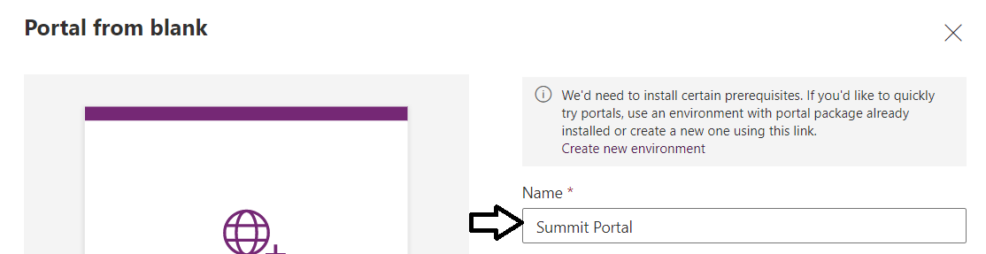

* 1. Enter a value for the portal **Address**. You might need to try several times if you pick an address that is already taken.

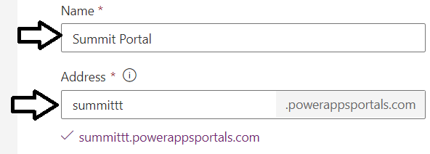

* 1. Once you have entered a **Name** and **Address** for your portal, click **Create** to begin the portal provisioning process.

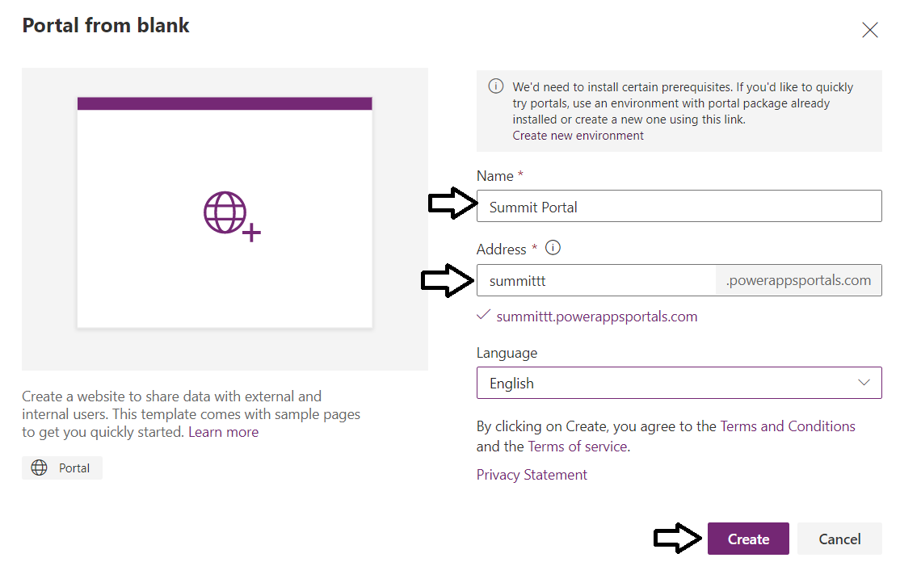

Once you click the **Create** button, it will take quite a bit of time before your portal is ready to use and edit. The entire provisioning process for a new portal can take from 30 to 60 minutes or even longer.

1. Inspect the apps in **My Dev Environment**.
   1. Click the **Apps** link in the left navigation to see the list of apps for **My Dev Environment**.
   2. You should see the portal app in a greyed-out site which indicates that the portal is being provisioned.

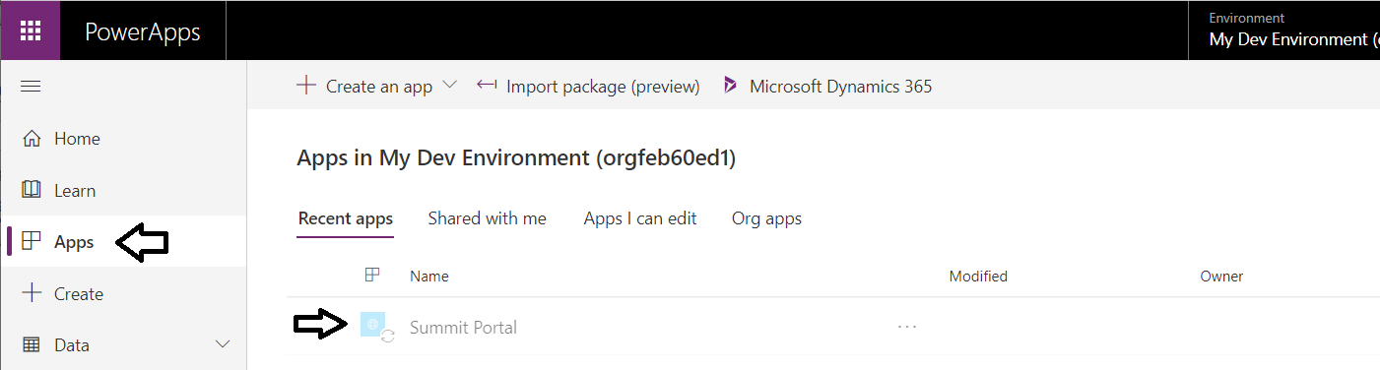

Since the provisioning process is not instant, you will not be able to work on our portal for a while. Therefore, you will begin working on a Power Platform solution with work that does not involve this portal. However, you have started the PowerApps portal provisioning process so later when it's time to work with your portal, it will be ready.

### Exercise 3 - Begin Work on a Conference Management Solution

Imagine you are organizing an internal conference (like Summit!) and you would like to build an app to allow internal attendees to browse sessions and see the details. You also will need a way for the conference administrators to input the session and venue information.

**SOLUTION OVERVIEW**: Power Platform technologies enable tech-savvy business users (aka “citizen developers”) to build a customized conference management solution. The application user interface and interaction logic are built in PowerApps, and the data is stored in the Common Data Service.

1. Review the key pieces of solution that you are going to build through this lab.
   1. A PowerApps canvas app that conference attendees can use
   2. A PowerApps model-driven app that conference admins can use to setup the data
   3. A PowerApps Business Card Reader
   4. A PowerApps Portal that external speakers can use to submit their session ideas
   5. A Business Process Flow that assists users in session management
   6. A Microsoft Flow that requests approval for sessions depending on capacity
2. Have a look at what you are going to build
   1. When you are done, you will have created a canvas app that allows the user to browse conference sessions,

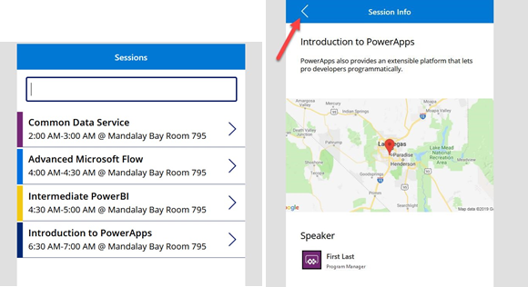

1. Import a Pre-existing Solution to Provide a Starting Point
   1. Navigate to <https://make.powerapps.com/>and make sure you are in **My Dev Environment**.
   2. Select **Solutions** and click **Import**.

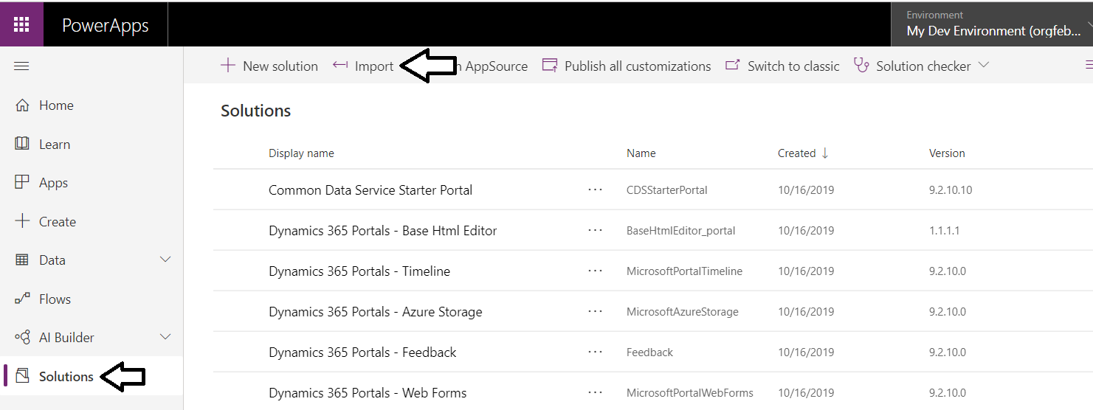

If you are prompted to log in, sign in using the same Office 365 account you have been using in this lab.

* 1. Select Choose File

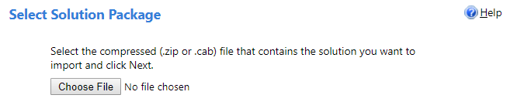

* 1. Select **ContosoConference** zip file located in the resources folder and click **Open**.

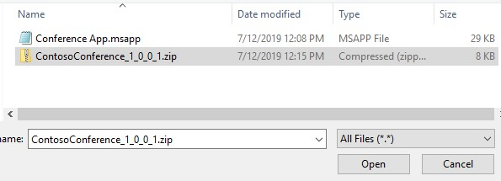

* 1. Click **Next**.

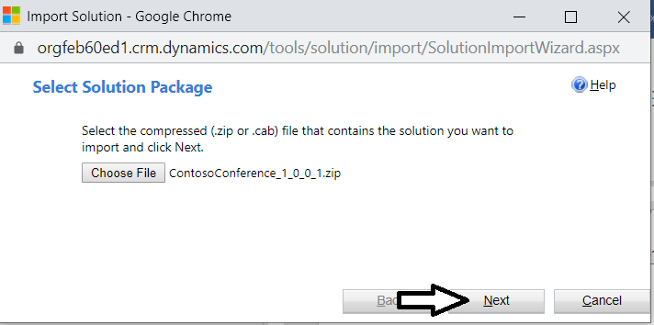

* 1. Click **Import** and wait for the importing to complete.

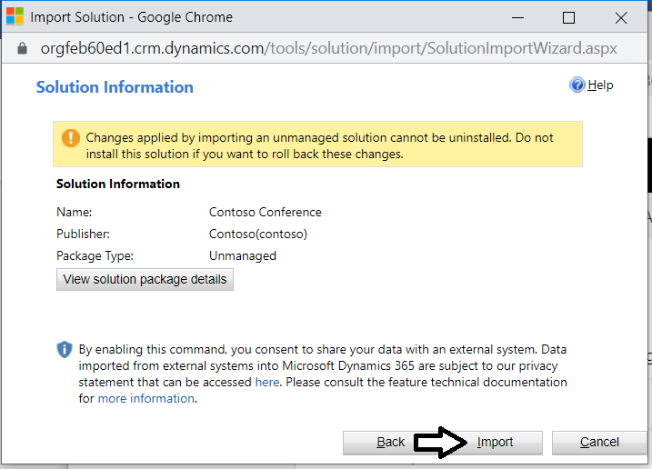

* 1. You should see a dialog that indicates the import is in progress,

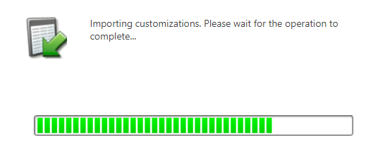

* 1. Click **Publish All Customizations** and wait for the publishing to complete.

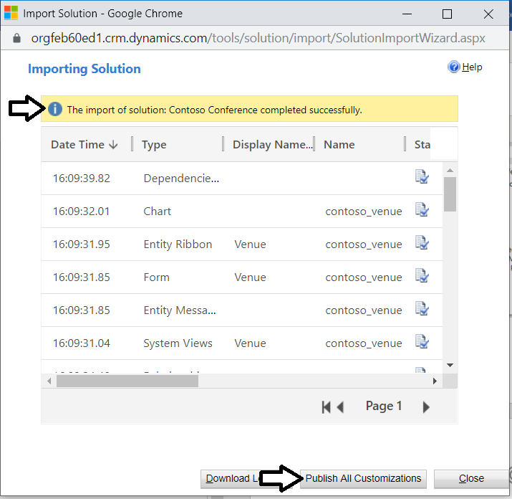

* 1. Click the Close button to close the **Importing Solution** dialog.

In this lab you will add new CDS components such as entities, canvas apps and model-driven apps into the **Contoso Conference** solution. In many real-world scenarios you will create your own CDS solution and then you will add your components into that solution. In this lab, you have been provided with a pre-existing solution with an entity as a starting point and you will continue to add components into that solution.

1. Inspect what's already inside the **Contoso Conference** solution.
   1. Click to open the Contoso Conference solution you just imported.

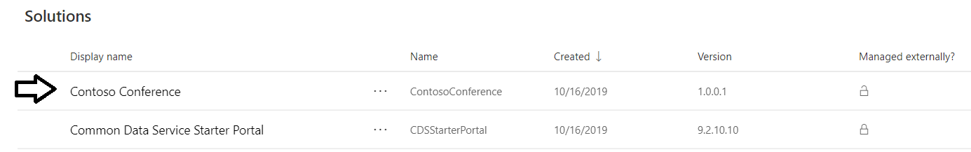

* 1. The solution should have one entity with the name **Venue**.

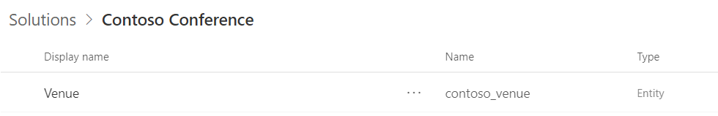

1. Create the **Session** entity.
   1. Make sure you are at the summary page for the **Contoso Conference** solution.
   2. Drop down the **New** menu and select the **Entity** command.

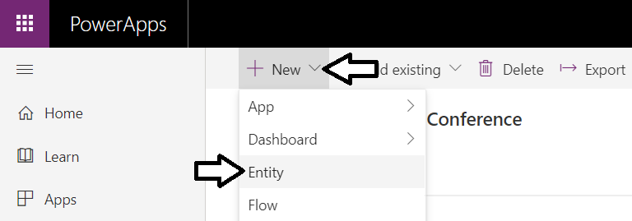

* 1. Enter **Session** for Display Name and click **Create**.

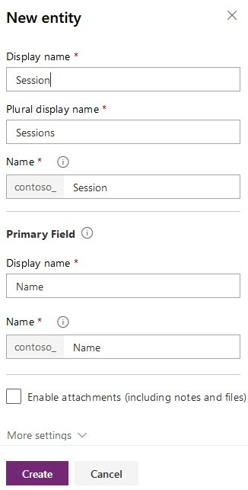

* 1. You should see a green information message indicating the entity has been created.

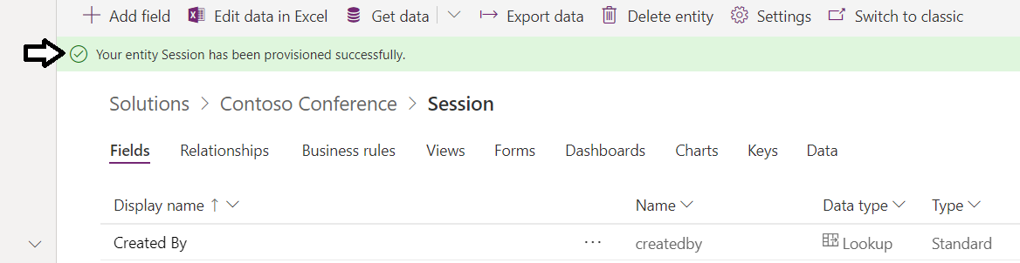

* 1. Close the green message by clicking the X at right-hand side.

1. Add the **Track** field to the **Session** entity.
   1. Make sure the **Fields** tab is selected and click **+ Add Field**.

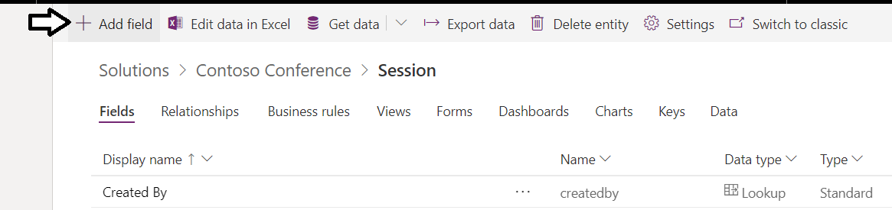

* 1. Enter **Track** for **Display Name** and select **Option Set** for **Data Type**.

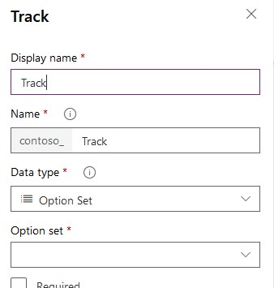

* 1. Click on the **Option Set** drop down and select **New Option Set**.

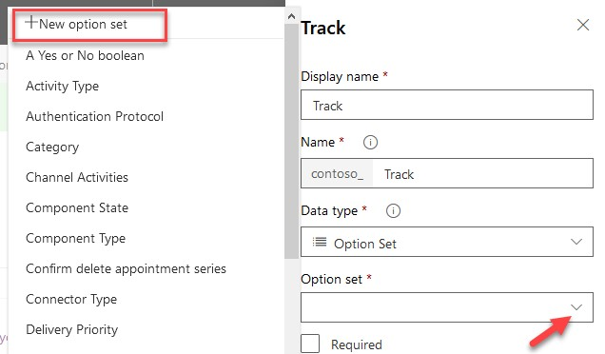

* 1. Enter **PowerApps** and click **Add New Item**.

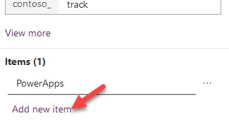

* 1. Enter **Microsoft Flow** and click **Add New Item**.
  2. Enter **AI Builder** and click **Add New Item**.
  3. Enter **CDS** and click **Add New Item.**
  4. Enter **Power BI** and click **Save**.

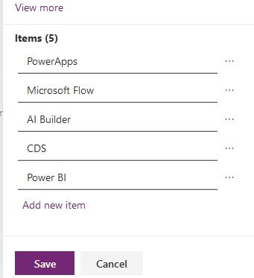

* 1. Check the **Required** checkbox and click **Done**.

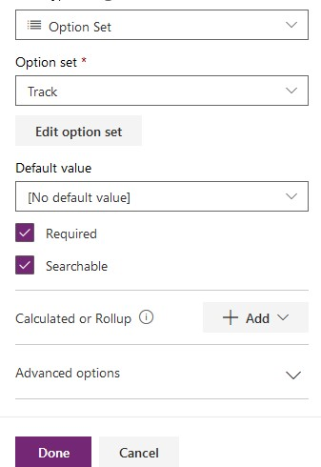

1. Add the **Description** field to the **Session** entity.
   1. Make sure the **Fields** tab is selected and click **+ Add Field**.
   2. Enter **Description** for **Display Name**.
   3. Select **Text** for **Data Type**.
   4. Expand **Advanced options** and set **Max length** to **1000**

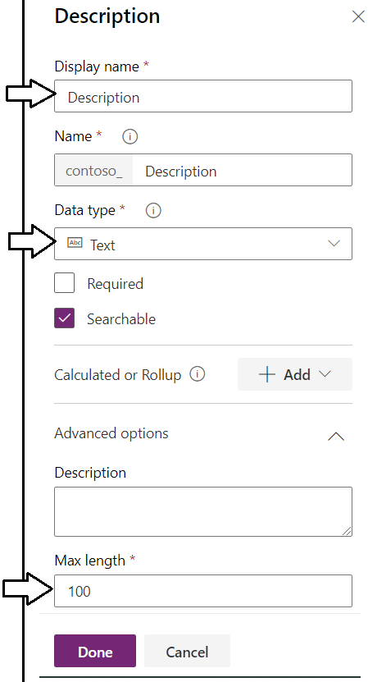

* 1. Click **Done** to add the new field.

1. Add the **Venue** field to the **Session** entity.
   1. Add **Display name** of **Venue**.
   2. Set the data type of **Lookup.**
   3. Select **Venue** as the **related entity**

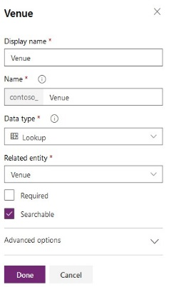

* 1. click **Done**.

1. Add the **Speaker** field to the **Session** entity.
   1. Add **Display name** of **Speaker**,
   2. Set the data type to **Lookup**,
   3. Set **User** as the Related entity..

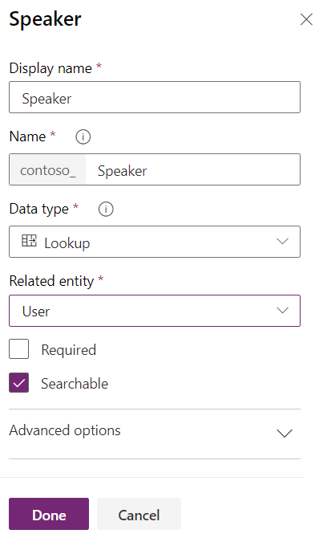

* 1. Click **Done**

Now that you have added a few fields with step-by-step instructions, you are now going to add several more fields without step-by-step instructions. Use the exact same steps that you used to create the first few fields when creating the additional fields.

1. Add eight more fields to the Session entity.
   1. Use the following table to add eight additional fields to the Session entity.

|  |  |  |
| --- | --- | --- |
| **Display name** | **Date type** | **Additional details** |
| **Start time** | Date and Time |  |
| **End Time** | Date and Time |  |
| **External Speaker** | Text |  |
| **Capacity** | Whole Number |  |
| **A/V Requirements** | Text | Max length 1000 |
| **Room Setup** | Text | Max length 1000 |
| **ADA Requirements** | Text | Max length 1000 |
| **Session status** | Option Set | Draft Waiting Approval Approved Rejected Published |

* 1. When you are done adding the fields to the Session entity, which the view mode for fields over to Custom.

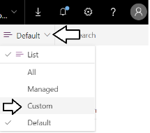

* 1. You should be able to see all the fields you added to the **Session** entity.
  2. Click **Save** entity.

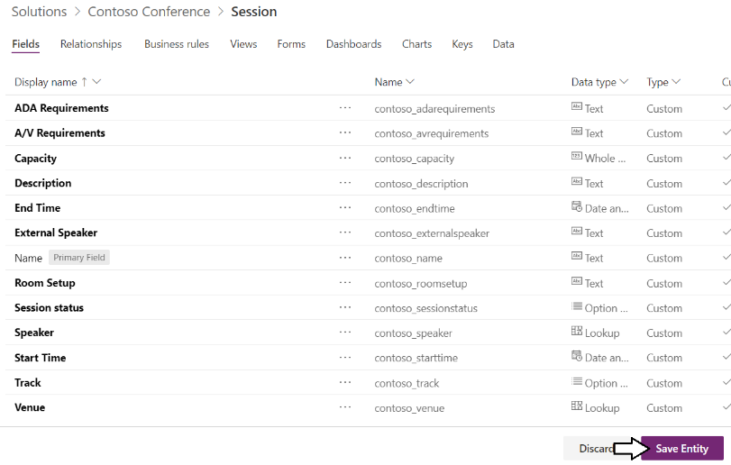

1. Add a new view to the **Session** entity
   1. Select the **Views** tab and click **+ Add View**

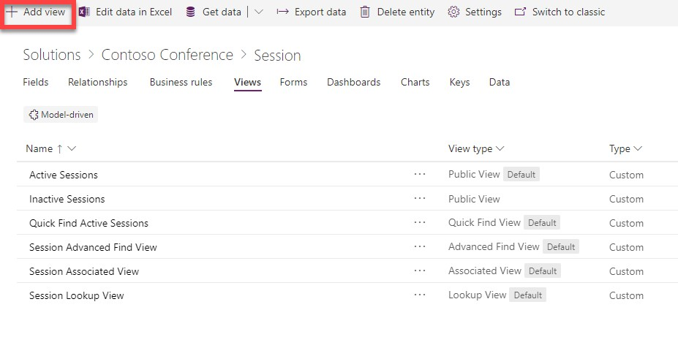

* 1. Enter a view **Name** of **Published Sessions** and click the **Create** button.

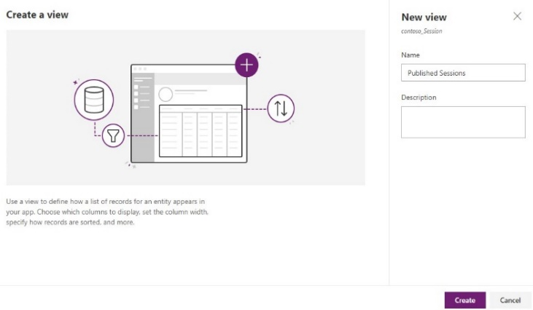

* 1. Click on **Capacity** to add it as a view header.

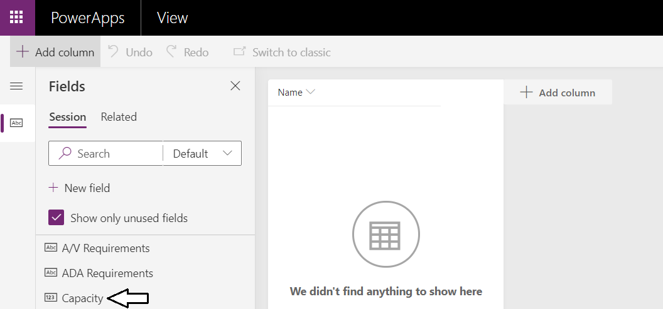

* 1. You should see the **Capacity** field has been added to the view.

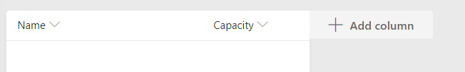

* 1. Add the following fields to your view: **Speaker,** **External Speaker**, and **Track.**



* 1. On the right of the screen, select **Edit filters**

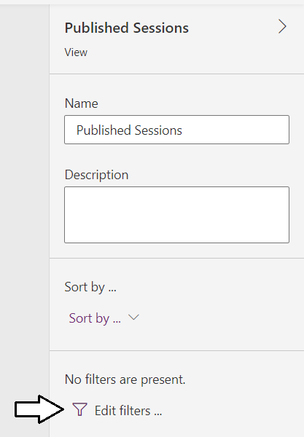

* 1. Click Add

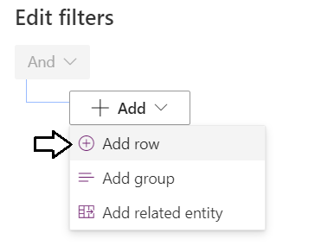

* 1. Configure the filter as shown below where **Session Status Equals Published**.

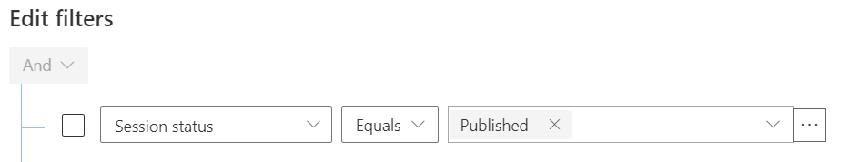

* 1. Click OK to save the fitler.

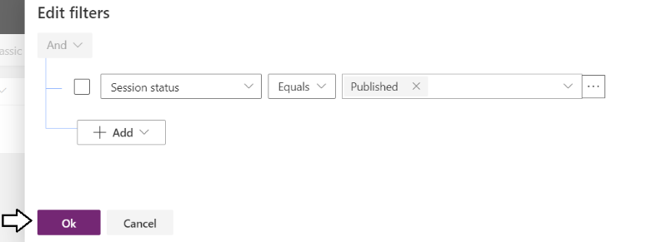

* 1. Verify that the filter is configure for **Session status is 'Published'**.

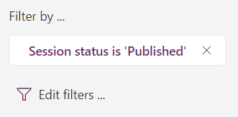

* 1. Click **Save** and click **Publish.**

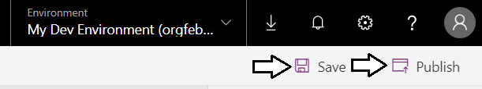

* 1. Close the browser tab.

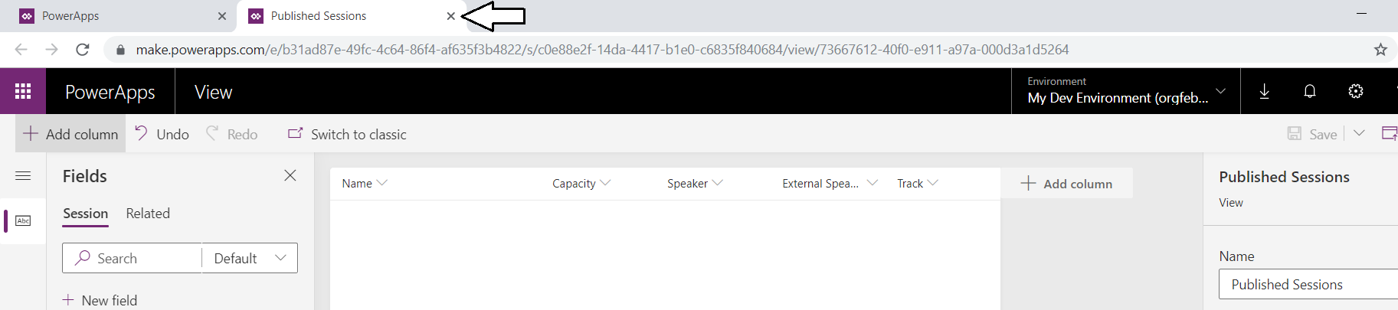

* 1. Click **Done**

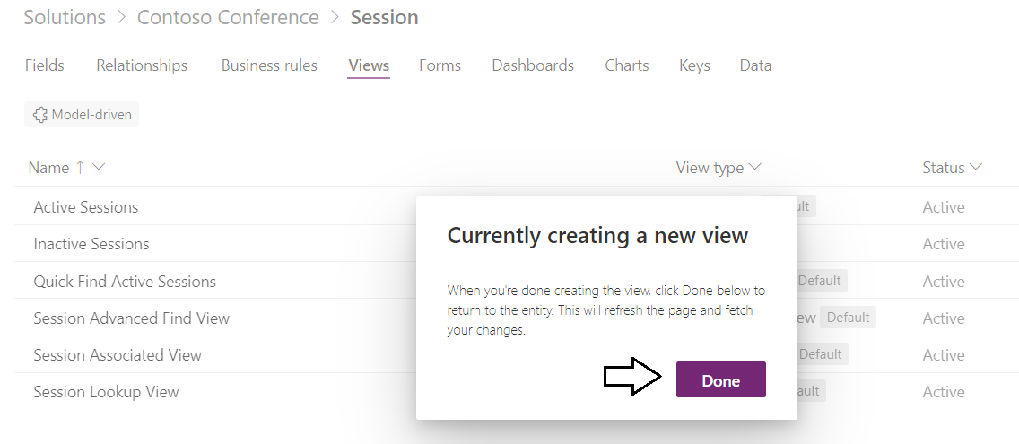

* 1. Verify you can see the **Published Sessions** view.

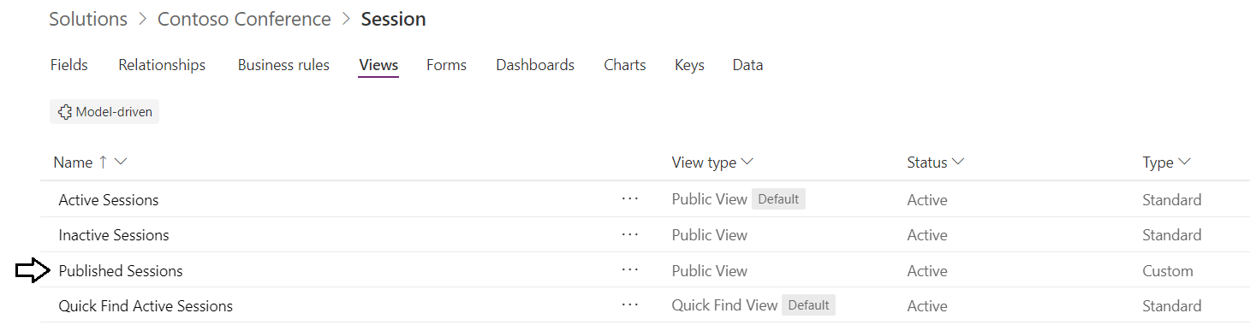

1. Customize the Main form of the Session entity.
   1. Select the **Forms** tab and click to open the **Main** form.

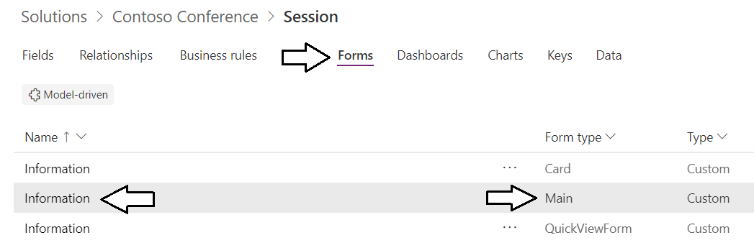

* 1. The form should be opened in the new forms designer.

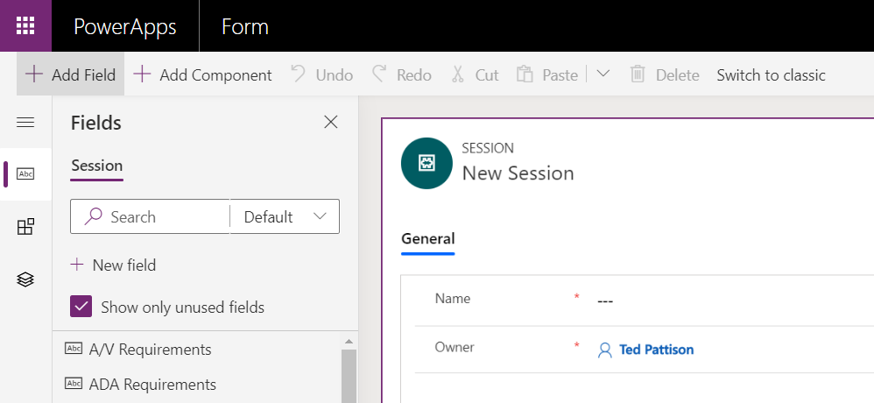

* 1. Drag the **Description** field and place it above the **Owner** field.

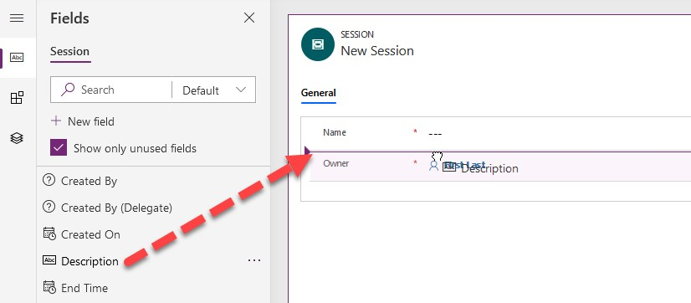

* 1. Drag the **Session status** field and place it above the **Owner** field.
  2. Drag the **Track** field and place it above the **Owner** field.
  3. Drag the **Start Time** field and place it above the **Owner** field.
  4. Drag the **End Time** field and place it above the **Owner** field.
  5. Drag the **Speaker** field and place it above the **Owner** field.
  6. Drag the **External Speaker** field and place it above the **Owner** field.
  7. Drag the **Venue** field and place it above the **Owner** field.
  8. Drag the **Capacity** field and place it above the **Owner** field.
  9. Drag the **ADA Requirements** field and place it above the **Owner** field.
  10. Drag the **A/V Requirements** field and place it above the **Owner** field.
  11. Drag the **Room Setup** field and place it above the **Owner** field.
  12. When you are done, the form should match the following screenshot.

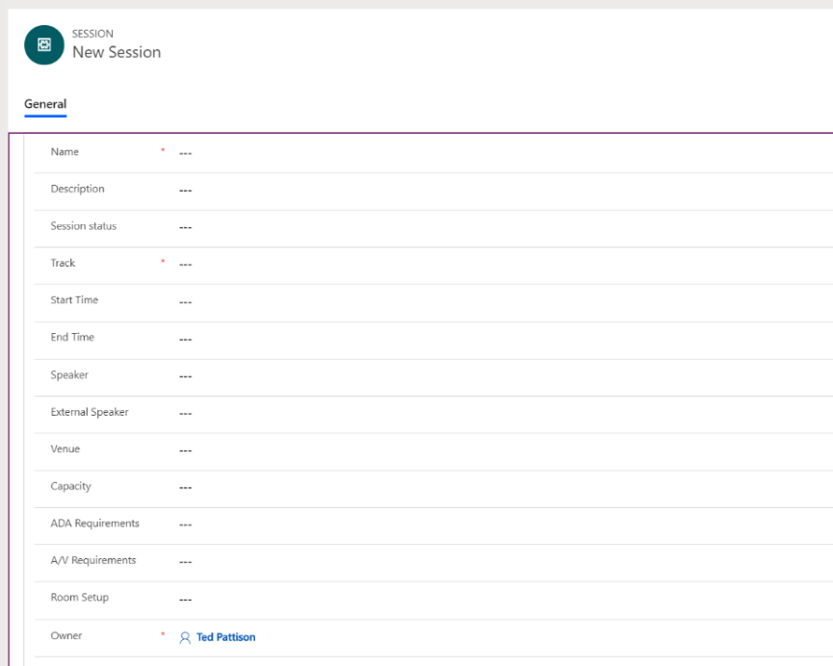

* 1. Click Save and then click **Publish**.

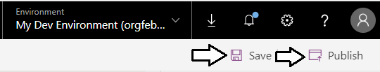

1. Publish all customization in the Contoso Conference solution.
   1. Return to the PowerApps maker using your browser back button.
   2. Select **Solutions**.
   3. Click **Publish All Customizations** and wait for the publishing to complete.

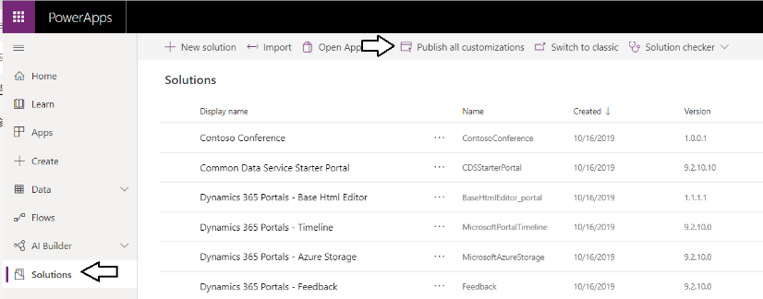

At this point you must change over to the other PDF file with the rest of the lab instructions.